Lab 12z – SQL

Place all answers into one .sql file an upload to Canvas. 24 total points, 2 bonus points.

1. Please create ***primary_key_sequence*** that goes up to 9999999.

[1 pts.]

1. Please create tables that match the ERD below and have their primary keys created automatically by ***primary_key_sequence.***

[5 pts.]

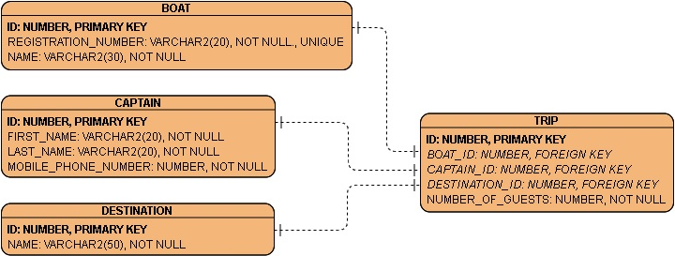

1. Please modify the tables as described below.

[5 pts.]

* BOAT
  + Add numeric column ***capacity*** with value required
  + Add date column ***registration_exp_date*** with value required
* CAPTAIN:
  + Rename column ***mobile_phone_number***to ***phone_number*.**
* TRIP:
  + Add numeric column ***number_of_crew*** with value required
  + Add date column ***start_date*** with value required
  + Add constraint *number_of_crew_check* that makes sure there are crew members on board each trip.
  + Rename table to ***trip_details***

1. Write insert statements that insert the following data.

[3 pts.]

* Into BOAT table:

|  |  |  |  |  |
| --- | --- | --- | --- | --- |
| ID | REGISTRATION_NUMBER | NAME | CAPACITY | REGISTRATION_EXP_DATE |
| DEFAULT | 'FL-12345' | 'PRANCING SEA HORSE' | 6 | '31-DEC-19' |
| DEFAULT | 'FL-54321' | 'SLOW AND STADY' | 11 | '31-DEC-20' |
| DEFAULT | 'FL-10101' | 'EAT MY BUBBLES' | 3 | '31-DEC-21' |

* Into CAPTAIN table:

|  |  |  |  |
| --- | --- | --- | --- |
| ID | FIRST_NAME | LAST_NAME | PHONE_NUMBER |
| DEFAULT | 'Becka' | 'Swifterson' | 1112221234 |
| DEFAULT | 'Birdy' | 'Bold' | 2223331234 |

* Into DESTINATION table:

|  |  |
| --- | --- |
| ID | NAME |
| DEFAULT | 'FANCY KEY' |
| DEFAULT | 'FUN CAY' |

* Once you are done, please run this query:

insert into trip_details (boat_id,captain_id,destination_id,number_of_guests,number_of_crew,start_date)

select

(select id from boat where name = 'EAT MY BUBBLES'),

(select id from captain where first_name = 'Becka'),

(select id from destination where name = 'FUN CAY'),

2,

1,

sysdate+14

from dual;

commit;

1. Create a view ***v_available_trips***,that shows trip details like below (date will be different). To do that, you will need to create a select statement to connect all the tables, pull relevant columns and give them names as below. Test your select before creating the view.

Hint for the ***max_number_of_guests*** column: the boat capacity is total of guests and the captain.  
[5 pts.]



1. Using subqueries, write statements showing the information:

[2 pts]

* Boats that are not booked for any trips
* Captains that are not booked for any trips

1. Create index ***fk_boat_id_ix*** on ***boat_id*** column of ***trip_details*** table.

[1 pt.]

1. Allow public to select from ***v_available_trips***.

[1 pt.]

1. Create a public synonym for ***v_available_trips***.

This might fail due to lack of privileges, but I want to see your command.

[1 pt.]

EXTRA 2 POINTS: Create drop statements for all your objects.